Tribal charter Certificate TEMPLATE.doc

PRINTING & FORMATTING NOTES

The TEMPLATE document is on page 2.

The static text, along with the intended fillable portions of this template use the True Type font Berlin Sans FE. You will need to have this font available on your system for the document to format and appear as intended. If not already installed on your system, the font is easily found on the internet as a safe download.

When filling in the intended text (Tribe name, Longhouse name, moons, Chiefs names) it is helpful to Hide the ¶ carriage return (Ctrl + *) to have a better visual view of how the printed certificate will appear.

If a name becomes too long to fit in the intended spaces, you can reduce the font size of that test portion as appropriate to fit the text in.

Material: The certificate is intended to be printed on a heavy card stock material such as a 65 lb. or 100 lb. paper so that it will look good in a frame. Depending on the printer being used, make sure that the paper stock is suitable for print systems such as laser, ink jet, etc. Also, for printing on heavy card stock, in your print media settings, use the selection that is best suited for your material.

Remember to print only page 2.
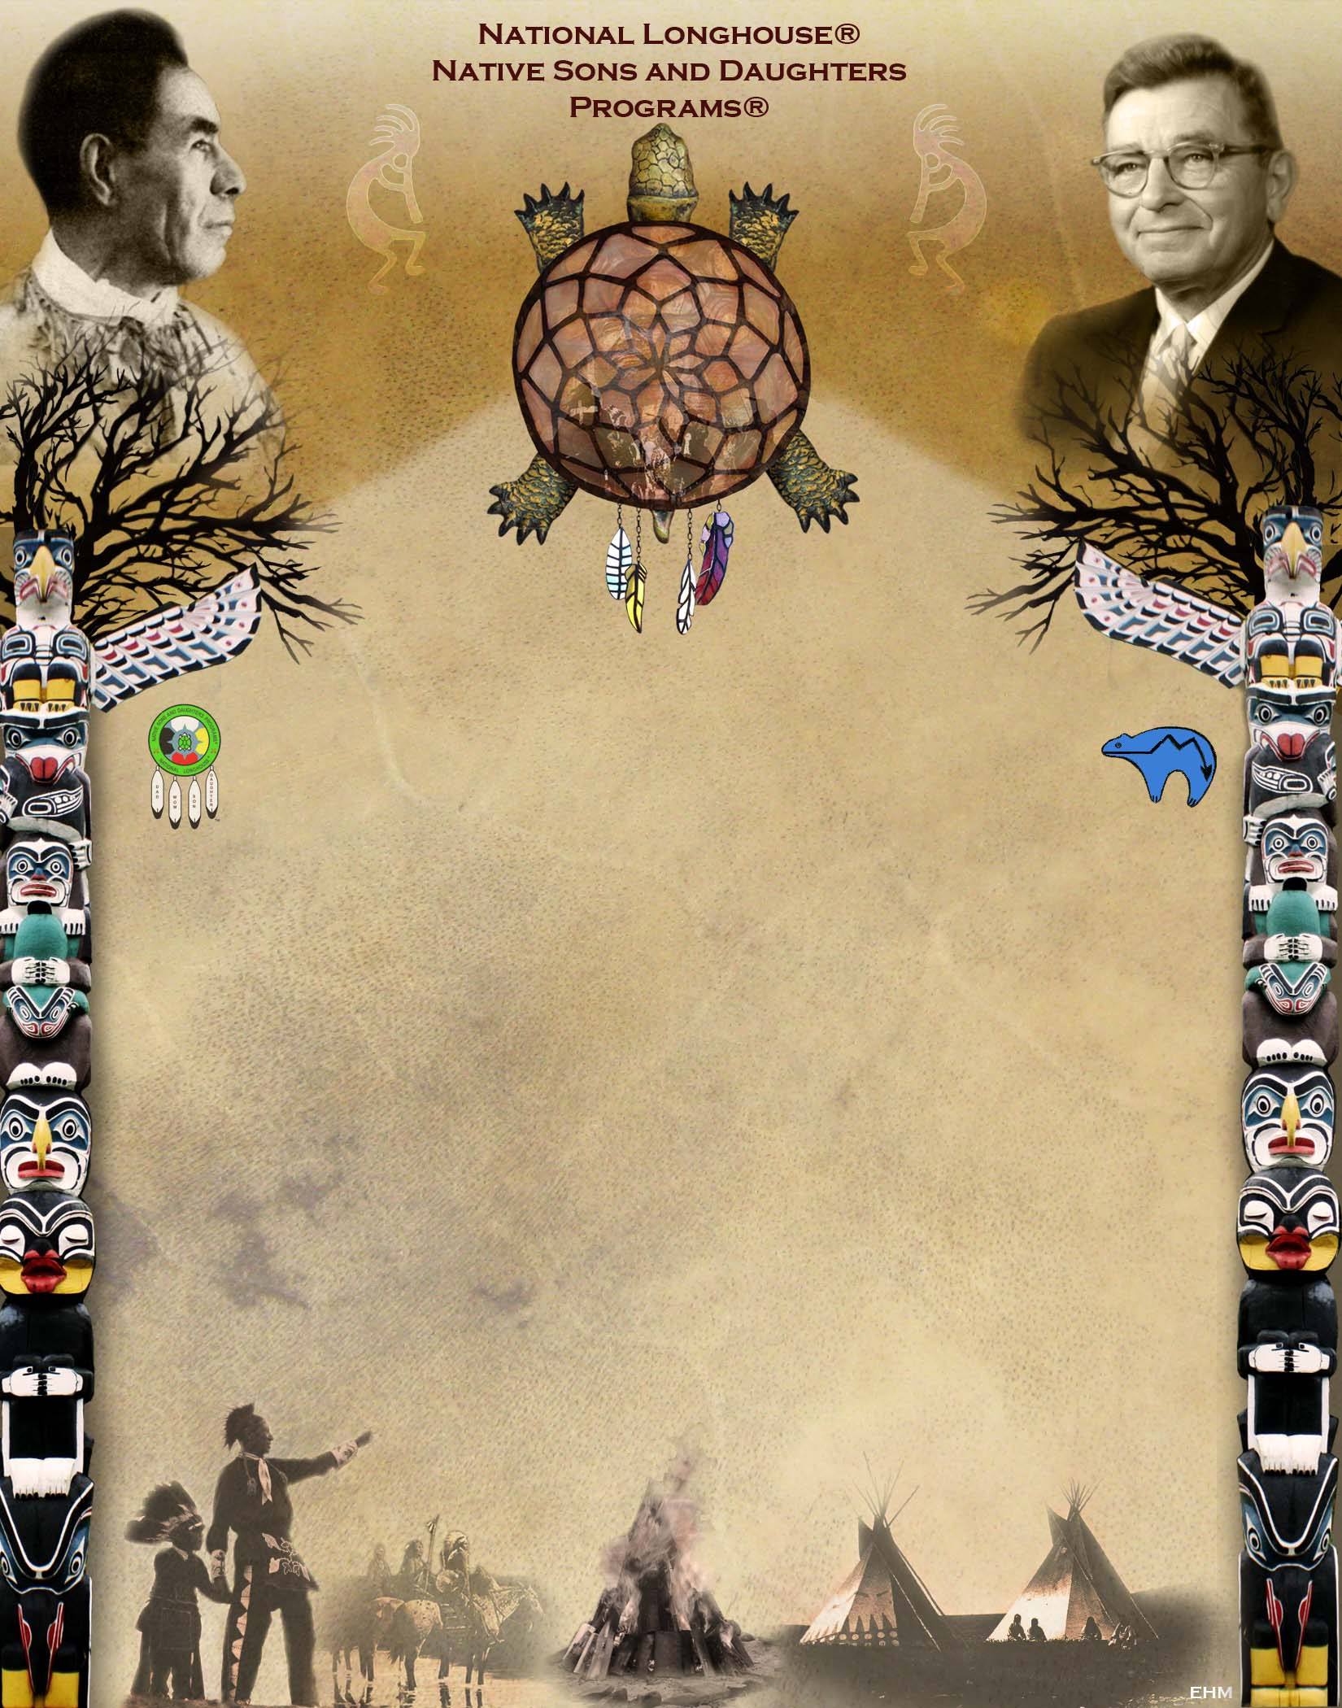
TRIBAL CHARTER
Hereby Granted To:
The (insert Tribal name) Tribe
Of The
(insert Longhouse name) Longhouse
During the (insert moon) Moon of the Year (insert year)

The Tribe Accepting this Charter Agrees…
To uphold the Aims and Ideals of the NSD Programs
To uplift the Parent & Child Relationship
To Strengthen the Family & Home
To help extend the NSD Programs to Others

(insert Longhouse Chief name/Indian name)
Longhouse Chief
(insert Tribal Chief name/Indian name)
Tribal Chief

